# Lab 7 – Basic Programming Structures in MATLAB

## Exercise

### Exercise 1

**Write function which takes an input array and returns the sum and product of its elements as outputs**

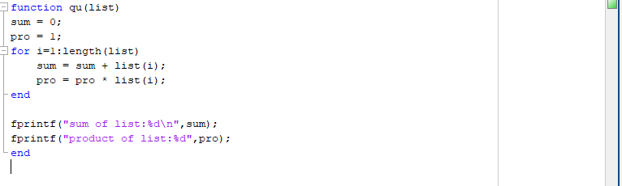



### Exercise 2

**Given the array:**

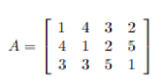

**use MATLAB statements to find:**

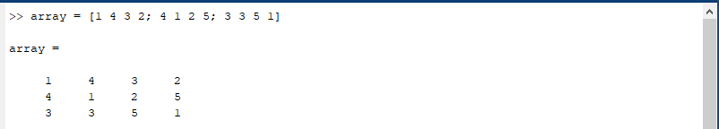

1. **The number of rows and columns in A**

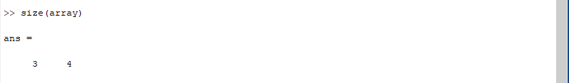

1. **The maximum and minimum element values in A**

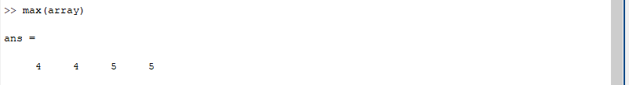

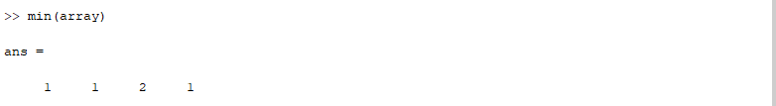

1. **The maximum and minimum element values in each row of A**

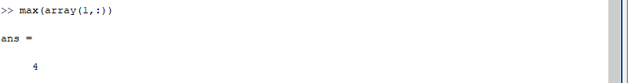

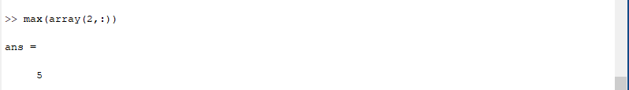

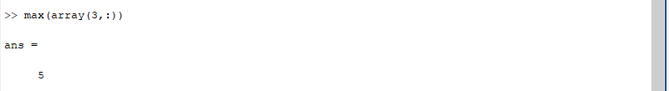

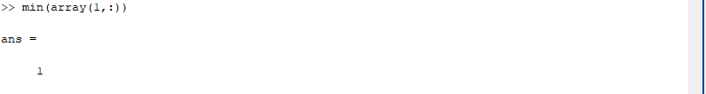

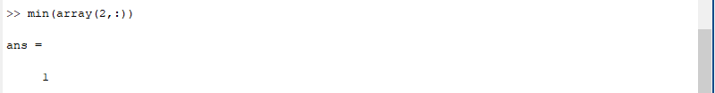

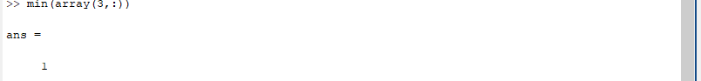

1. **The average value in each column**

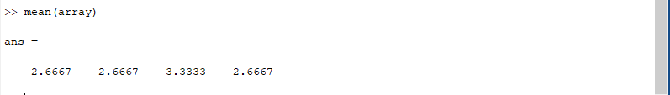

1. **The average of all element values**

